Walk 12 Harewood End
Last walked in December 2015

Description. A 6 km (3.7 mile), hilly walk along straight bridleways, up a little valley with some nice views along good terrain. Don’t go when it’s to wet.
Start. Park the parking area across the road from Harewood End Inn. Explorer Map 189 Grid 529269
Direction from Belmont roundabout (Turn milometer to zero). Take the A49 to Ross-on-Wye, and after 8.8 miles TR and park in the parking area opposite houses.

Harewood Park, situated in a quiet valley between Hereford and Ross on Wye, is a 900 acre estate which the Duchy of Cornwall, (owned by Prince Charles and Camilla) bought as part of the Prudential purchase in 2000. When the Duchy of Cornwall acquired the estate in May 2000 they made plans to breathe new life into what had become an abandoned group of farmsteads within Herefordshire, (The Duchy of Cornwall is a private estate which funds the public, charitable and private activities of The Prince of Wales and his family). The Duchy has been the driving force behind plans to revitalise the cottages and buildings on the estate and this positive rural regeneration project has already created jobs and homes in the area. In 2003 plans were prepared for the estate’s rural regeneration project that would take an estimated eight years to complete at a cost of approximately £8-9 million. The scheme was designed by consultant architect Craig Hamilton and dealt with the sympathetic and sustainable restoration of three groups of buildings at Home Farm, Grange Farm and Harewood Park itself. The scheme, which received considerable support from the local Planning Authority and the surrounding inhabitants of the area, was designed to provide an inspirational place for people to live and work but also to save the structures from the plight of decay and collapse.

1. Harewood End Inn. A Traditional country pub and restaurant, 5 letting bedrooms all en-suite facility in the beautiful Herefordshire countryside. Large home cooked menu available daily. Go back to the main road and cut straight across it, to walk along the tarmac Bridleway that’s to the R hand side of Harewood End Inn. Pass a garage on your R and for over  km you go along a narrow enclosed dirt track that will widen out into a tree-lined avenue, you then go thru a way marked metal gate and onto a wide stony farm track. Go straight ahead along the farm track for well over  km to reach Woodlands Farm.

2. Woodlands Farm. Continue ahead between farm buildings to exit by a wooden gate on the L, (in front of silos), onto a grassy avenue. Walk along the avenue for about 100m to go thru a wooden gate into {F1} and continue along the L hand edge of this field. Keeping the fence on your L you continue on for another  km, going under power lines and passing trees on your L, to reach the corner of the field where you cross over a stile by a metal gate into {F2}. TR and walk along the top of the field for about 100 metres, then TL and descend the field, straight down past stables and a house on your L to go thru a metal gate and onto the tarmac road.

3. Tarmac Drive. TL, a little way along the drive you go thru a wooden gate onto a grassy track. Carry on in the same direction passing a pond on your R, and then go thru a wooden gate below the start of a wood on your L. Carry on for about a kilometre up the valley, passing underneath power lines, going thru a metal gate and then passing a wooded area on your L. Near the end of the field, on the L hand side, go thru a metal gate and on up an enclosed avenue, to go past a restored old farmhouse on your L.

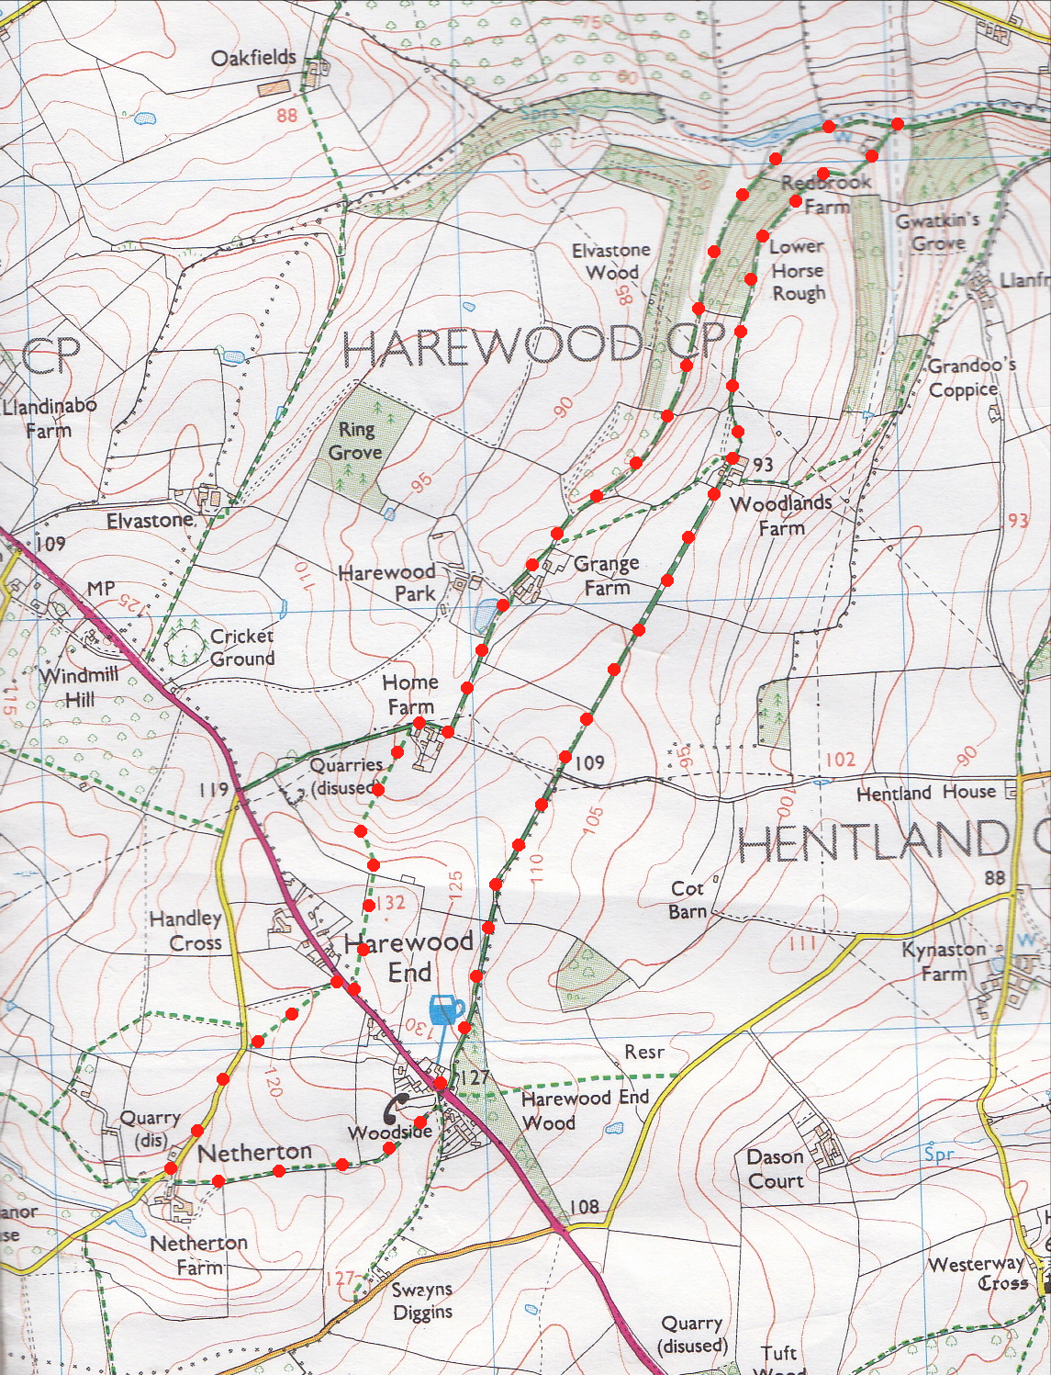
4. Grange Farm. Bear R across a stony drive onto tarmac drive/lane and continue along lane. Ignore drive into St Denis Chapel, which is on your R, and ignore the drive further along the lane on your L, which goes to Grange Farm. St Denis’s Chapel is part of a comprehensive regeneration project of Harewood Park. Originally the private chapel to the estate, this is the third chapel on the site and dates from 1864. Follow the lane to a road junction and TR at a small pond, (if its still there) in front of Home Farm. Immediately passed the farm, (now on your L), you TL and go up 7 wooden steps and thru a small wooden gate into {F3}. Keep to the fence and the L hand edge of the field until the fence turns sharp L, at this point you go straight across the field, going up the steep hill to cross over a stile at the top into {F4}. Walk on in the same direction and then follow the R edge of this field. As you pass a house on your R the field edge will bend L, and after about 100m you TR to cross over a stile in a hedge to get onto the main road.
3

5. Harewood End. TR and walk along pavement for 35 metres and cross over the A49 to cross over a stile opposite and into {F5}. Go straight across and down the field to cross over a hidden stile which is just R of the bottom field corner, then go down steps and onto a road, (if the stile is to overgrown then go thru the metal gate in the corner, turn sharp R and go thru another metal gate and onto the road). TL to snake down the road to the first house on the L which is Netherton Farm.
4
2

6. Netherton Farm. TL towards the house and walk about 30 metres up the L most drive and just before the metal gate TL up a grassy channel. Cross the stile, which is on the L of the metal gate, into {F6} and follow the R edge of the field, hedge is on your R. Carry on to the end of the field and cross a stile/metal gate and continue along the R edge of {F7} to cross another stile in the top R hand corner into {F8}. TL, follow the L edge of this field to cross another stile on the L and go along an enclosed track between fences to a telephone kiosk which is opposite Harewood End Inn.
5
6
1

